QuickBite Menu Optimization & Category Price-Point Analysis — Capstone Project

Business Problem
QuickBite wants to improve its restaurant menu offerings and pricing strategy, but management lacks a clear understanding of how menu prices vary across categories and cuisines, which items are priced unusually high or low, and where menu variety could be improved.
Problem Statement
Menu Optimization & Category Price-Point Analysis: Assess price distribution across menu categories, such as Starters, Main Course, Beverages, and Desserts, and cuisine types to identify pricing patterns, potential pricing optimization opportunities, and underrepresented menu categories.
Executive Summary
This project analyzes QuickBite's menu data covering category-level pricing, cuisine-wise price comparisons, price benchmarking, menu representation, and restaurant-level price rankings.
The dataset contains 40 menu items across four categories and 20 restaurants. Main Course has the highest average price at ₹439.11, while Dessert has the lowest at ₹304.35. The overall average menu-item price is ₹379.36, and half of the menu items fall within the ₹401–₹600 price band.
Cuisine-level analysis identifies Multi Cuisine as the highest-priced cuisine group by average item price, at ₹562.85, while Indian cuisine has the largest representation with 10 items. The analysis also reveals that all 20 restaurants offer only one menu category in the supplied data, indicating limited category diversity within individual restaurant menus.
Dataset Overview
Dataset characteristic | Value
Total menu items | 40
Total restaurants | 20
Menu categories | 4
Cuisine labels | 14
Overall average item price | ₹379.36
Median item price | ₹410.70
Highest item price | ₹635.75
Lowest item price | ₹123.44
The analysis uses the menu_items and restaurants tables, joined using restaurant_id.
1. Category Price Distribution
Objective: Understand how prices vary across menu categories and identify the categories with the highest and lowest price points.
Key findings
Category | Items | Average price | Minimum price | Maximum price
Main Course | 10 | ₹439.11 | ₹134.06 | ₹627.32
Beverage | 10 | ₹402.25 | ₹169.16 | ₹592.86
Starter | 10 | ₹371.73 | ₹133.26 | ₹635.75
Dessert | 10 | ₹304.35 | ₹123.44 | ₹506.76
Average Menu Price by Category
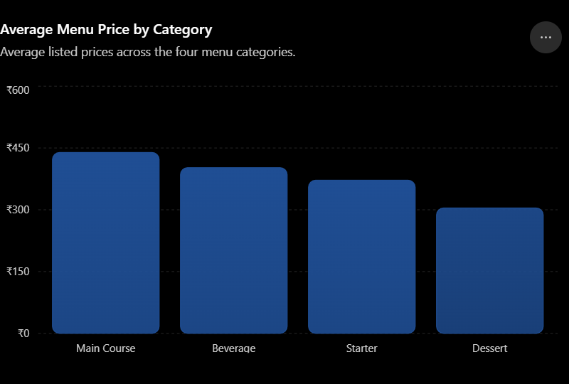
Analysis
- Main Course: The highest average price is ₹439.11. This category may warrant a closer look at item positioning and the factors contributing to its relatively high average.
- Beverage: The average price of ₹402.25 is higher than the Starter and Dessert averages, suggesting that beverage pricing deserves examination rather than an assumption that all beverages are inexpensive.
- Starter: The price range spans ₹133.26 to ₹635.75, a difference of ₹502.49. This is the widest range among the four categories.
- Dessert: The lowest average price is ₹304.35, approximately 30.7% below the Main Course average.
Business insight: QuickBite has substantial price variation within categories, particularly among Starters. Management should examine unusually priced items against their portions, ingredients, restaurant positioning, and comparable offerings. The lower Dessert average may also justify examining the range of dessert options available.
2. Cuisine-Level Pricing Analysis
Objective: Compare average menu prices and menu-item counts across cuisines to identify high-priced cuisine groups and differences in menu representation.
Average Price by Cuisine
Comparison of average menu-item prices by cuisine. Groups with two items have limited representation.
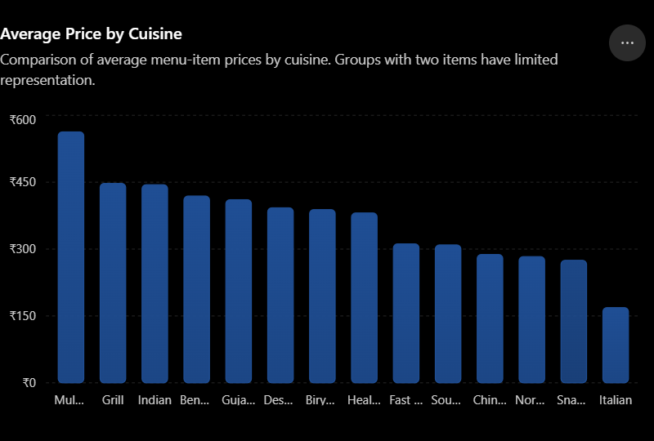
Analysis
- Multi Cuisine has the highest average price at ₹562.85, but this is based on just two menu items.
- Indian cuisine has the largest representation, with 10 items and an average price of ₹444.37.
- Grill has an average price of ₹447.30, slightly higher than Indian cuisine, but only two items are represented.
- Italian cuisine has the lowest average price at ₹168.67, based on two items.
- Bengali and South Indian cuisines each have four items, while the remaining cuisine groups have two items each.
Indian cuisine accounts for 25% of the menu dataset, while Multi Cuisine and Grill have higher average prices but much smaller samples.
Business insight: QuickBite's menu data is concentrated in Indian cuisine, while several other cuisines have limited representation. The high average prices for Multi Cuisine and Grill could reflect the particular items included rather than a general market pricing pattern.
3. Price Benchmarking and Price-Tier Classification
Objective: Identify items priced above the platform average, compare items with their category averages, and classify them into relative price tiers.
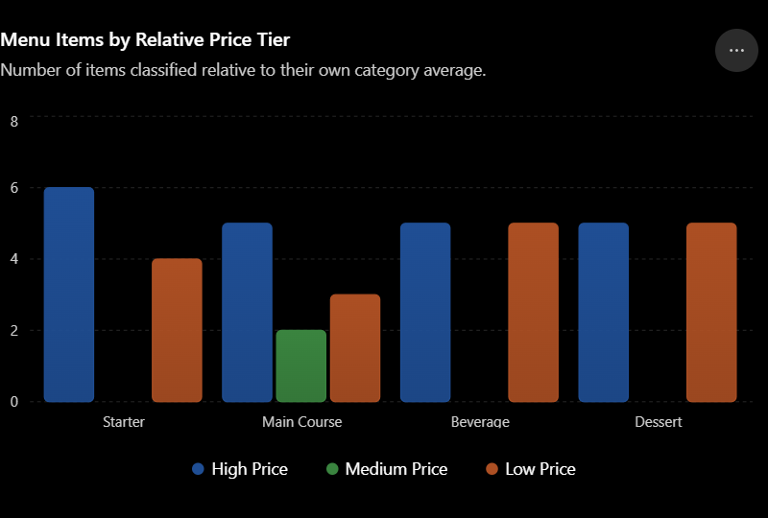

Analysis
- 21 items are classified as High Price relative to their category averages.
- 17 items are classified as Low Price.
- Only two Main Course items fall into the Medium Price tier.
- Starters have six items in the High Price tier, the largest number among the categories.
- Beverages and Desserts each have an even split between High and LowPrice items.
The category-average comparison identifies 22 items priced above their own category average. This differs from the 23 items above the overall platform average because each benchmark uses a different reference value.
Business insight: The classification provides a way to flag price outliers for investigation. The Starter category has several relatively high-priced items, while Beverages and Desserts show substantial variation around their respective averages.
Strategic Recommendations
1. Menu pricing optimization
- Review unusually high-priced Starter and Main Course items.
- Benchmark prices against comparable items across restaurants.
- Evaluate low-priced items against ingredient costs and commission expenses.
- Test price adjustments on selected items and measure the effect on sales.
2. Cuisine-level strategy
- Examine Indian cuisine because it has the largest menu representation.
- Investigate whether the smaller cuisine groups need additional variety.
- Avoid treating a high average price as proof of stronger profitability.
- Standardize cuisine labels for more reliable comparisons.
3. Menu assortment improvement
- Verify whether the 20 restaurants genuinely offer only one category or whether the dataset contains only a subset of their menus.
- Test complementary categories at selected restaurants if demand supports expansion.
- Use customer preferences and item-level sales to identify assortment gaps.
4. Restaurant benchmarking
- Review Bengal Spice and Capital Kitchen as candidates for price-positioning comparisons.
- Investigate the highest-priced items within each cuisine.
- Include ratings, portion sizes, costs, and sales performance in future comparisons.
5. Improve data quality
- Replace generic item names such as Item 34 with actual menu descriptions.
- Standardize cuisine labels and category naming.
- Collect item-level quantities sold, revenue, discounts, ingredient costs, and commissions.
- Track customer feedback and ratings by menu item.

Final Conclusion
The QuickBite Menu Optimization & Category Price-Point Analysis uses 20 SQL queries to examine menu pricing, cuisine-level differences, relative price tiers, menu representation, and restaurant-level pricing.
The analysis finds that Main Course has the highest average category price at ₹439.11, while Dessert has the lowest at ₹304.35. Multi Cuisine has the highest average price among cuisine groups at ₹562.85, although it is represented by only two items. Indian cuisine has the largest representation with 10 items, and all four menu categories have equal overall counts.
The price-tier analysis identifies 21 High Price items, 17 Low Price items, and two Medium Price items relative to category averages. The assortment analysis also reveals that every restaurant in the dataset offers just one category, while Main Course has the narrowest coverage across cuisine groups.
These findings help QuickBite identify items for price review and areas for further menu investigation. However, the current data does not establish optimal prices, customer demand, or actual profitability because it lacks item-level sales and cost information.
Overall outcome: QuickBite gains a structured SQL-based view of menu pricing and assortment, together with actionable areas for further investigation. Integrating sales, cost, and customer-feedback data would enable the platform to move from descriptive analysis toward evidence-based menu optimization.

